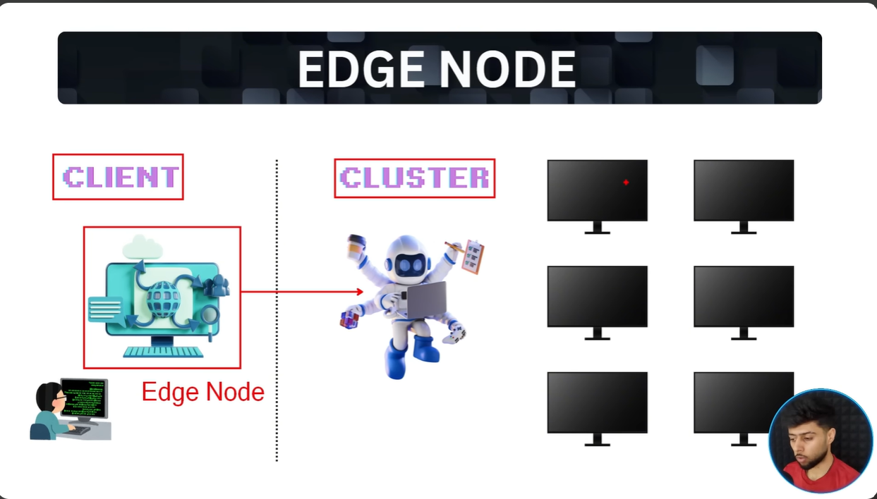

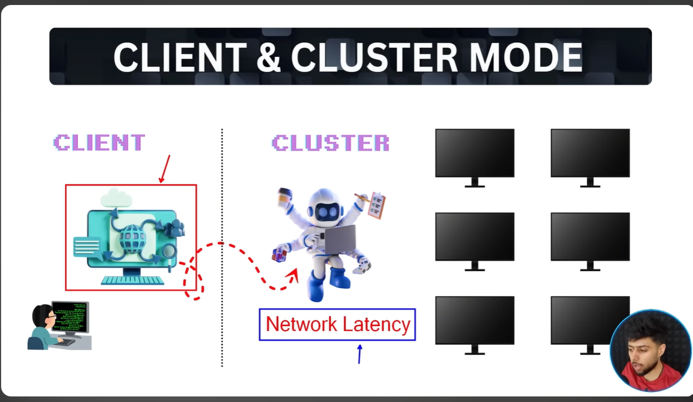

An edge node is a secure gateway machine that acts as the entry point for users to access the cluster, whereas a client node is the machine where the Spark driver runs to plan, submit, and manage job execution.
Note : In Dev environment, we run driver program on client node ,but in higher environment there should be a separate driver node otherwise it would introduce network latency.

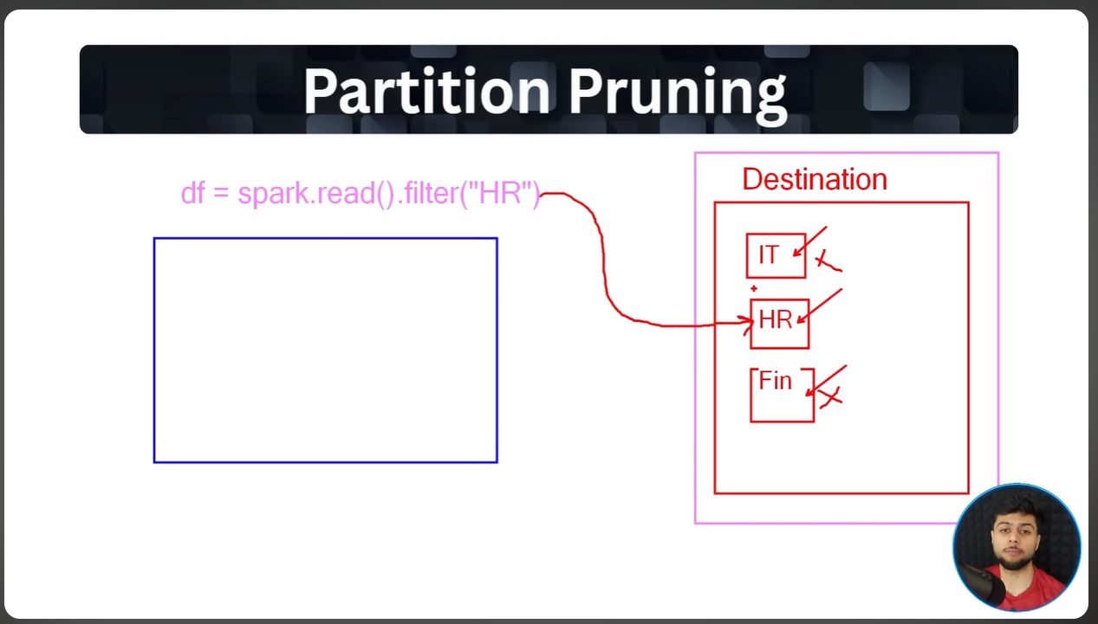
Please refer https://dbc-ab1aa973-0c27.cloud.databricks.com/editor/notebooks/3213986030460209?o=4329490874745353#command/8418017044796347

